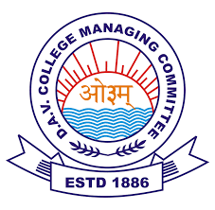

D.A.V.PUBLIC SCHOOL , NTPC , FARIDABAD
CIRCULAR
DATE: 5.09.2020

Dear students,
Parents are a child's first teacher who gives them life lessons and after them comes the Guru or teacher who leads the child ahead in life. In young and impressionable years of child ,teachers play very important role . They being role models inspire and parent-figures outside of their homes. They teach many lessons about life. At times they might be tough on students but in hindsight, it is only to mould and shape talents of their students to make them fight their fears and to work on their weaknesses. In fact, good teachers not only imparts knowledge to their students but they inspire, encourage and instil curiosity to find solutions to problems. To honour these remarkable people in our lives, Teachers' Day is celebrated as an important day worldwide. For instance, in the United States, it is celebrated in the first week of May; in the United Kingdom, it is celebrated on October 5. Meanwhile, in India Teachers' Day is celebrated annually on September 5 which also marks Dr Sarvepalli Radhakrishnan's birth anniversary.
To honour and celebrate your beloved teachers on this special occasion you have shared your love, respect and gratitude in different ways.We all are overwhelmed for your love and regards for us.
Though this day is celebrated as a teacher 's day each year but I want to dedicate this whole day and celebrations to all of you .We appreciate all of you being so disciplined and sincere learner during your online classes.
Thanks for being so obedient and sincere during this new normal phase of life during Covid pandemic.
I am sending my love and blessings to all our students for making the day memorable one for all of us.

Regards
Alka Arora
Principal

